
Invitation for NZISF seminar on 11 December (on ZOOM)
 or use QR code: 
Seminar topic: Make your Application Programming Interface more secure: a guide for setting up the GraphQL tool without going around in circles
GraphQL is gaining traction as a way to expose your API's with a consistent interface. By acting as a common layer in front of your internal API's and microservices, GraphQL proxies and transforms your API traffic and provides a rich query syntax allowing a great developer experience.

Presenter: Kirk Jackson

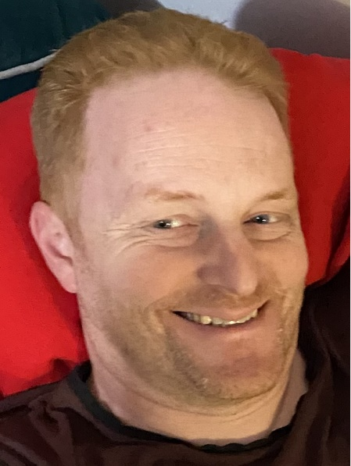
Kirk Jackson works at Lightspeed, and has previously helped lead the OWASP Wellington meetup and the annual OWASP NZ Day in Auckland.
Kirk worked as a web developer before switching to the defence team - setting up Xero's security practice, working as a pen tester, a web security researcher at RedShield and in defence roles at several companies.

Details for registration:
- Registration fee: $10.00.
- Registrations will be accepted until 0900h, on Wednesday, the 10th of December.
- ZOOM login will be circulated to attendees on Wednesday, the 10th of December.


Our partner:

Our sponsors:

Our website:
http://www.nzisf.org.nz
To place your name on the NZISF mailing list, click here
To remove your name from the NZISF mailing list, click here
Lech Janczewski
NZISF Chair

